Donark patel
CSC-161-60
Lab 3 Worksheet
(Hand in with Lab, Complete and get approved before you write code)

INPUTS (What information must the user supply)

Name | Data Type | Description
roomOneSideA | Float | Room 1 Side A
roomOneSideB | Float | Room 1 Side B
roomTwoSideA | Float | Room 2 Side A
roomTwoSideB | Float | Room 2 Side B
roomThreeSideA | Float | Room 3 Side A
roomThreeSideB | Float | Room 3 Side B

Outputs (What information must you provide the user)

Name | Data Type | Description
roomOne | Float | Total area of room 1
roomTwo | Float | Total area of room 2
roomThree | Float | Total area of room 3
costPerSquareFeet | Float | Cost of carpet per square feet
costRoom1 | Float | Cost of carpet of room 1
costRoom2 | Float | Cost of carpet of room 2
costRoom3 | Float | Cost of carpet of room 3
totalArea | Float | Total Area of 3 rooms
totalCost | Float | Total cost of the carpet of 3 rooms

Calculations (all calculations required to get outputs above including intermediate calculations)

Name | Data Type | Calculation | Description
roomOne | Float | roomOneSideA * roomOneSideB | Calculating area of room 1
roomTwo | Float | roomTwoSideA * roomTwoSideB | Calculating area of room 2
roomThree | Float | roomThreeSideA *  roomThreeSideA | Calculating area of room 3
costRoom1 | Float | costPerSquareFeet * roomOne | Cost of carpet of room 1
costRoom2 | Float | costPerSquareFeet * roomTwo | Cost of carpet of room 2
costRoom3 | Float | costPerSquareFeet * roomThree | Cost of carpet of room 3
totalArea | Float | roomOne + roomTwo + roomThree | Total area of 3 rooms
totalCost | Float | costPerSquareFeet * totalArea | Total cost of carpet (3 rooms)

Output Format (Write exactly what the screen should look like when you are done)

Company Carpet
Date
Invoice
Room1 Room 2 Room 3
Area 123 123 123
Cost $123 $123 $123
Total Area: 123
Total Cost: $123

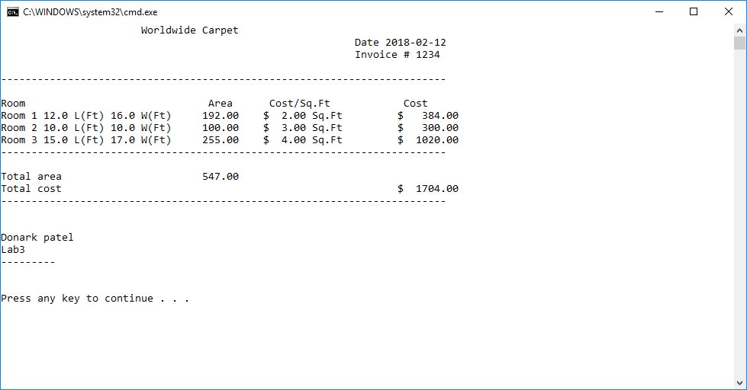

Donark Patel CSC-161-60
Lab - 3

